Tutorial: Connecting MongoDB Compass with MongoDB Atlas and Exploring the MongoDB Dashboard

- Log in to MongoDB Atlas using your Google account or create a new account.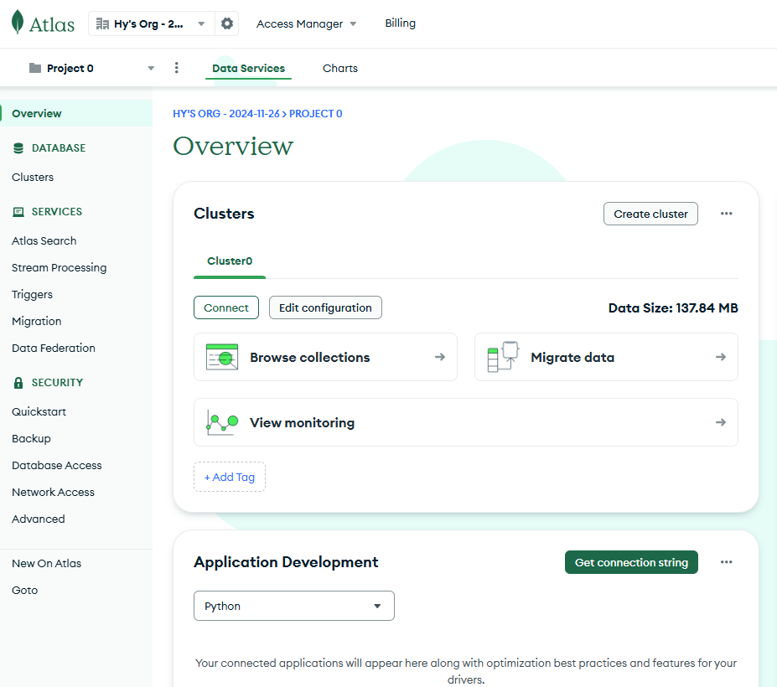
- Click Connect, select Compass, copy the connection string, and then open MongoDB Compass.

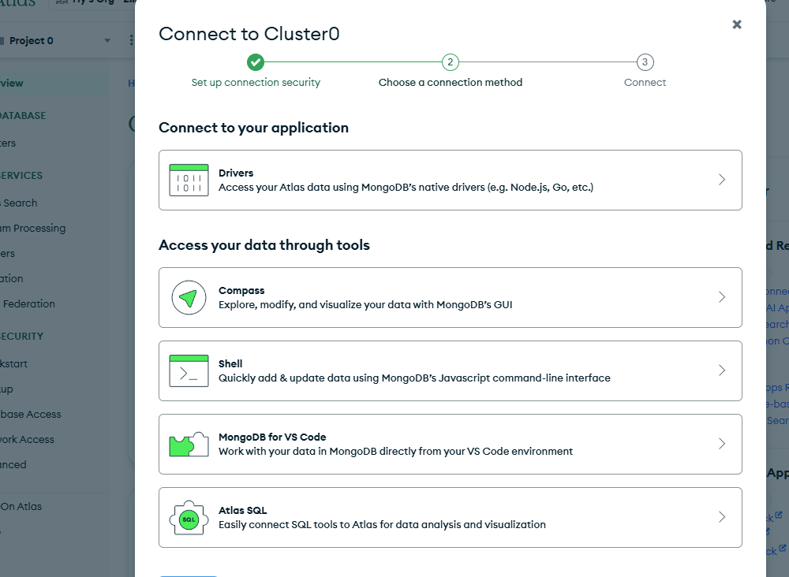
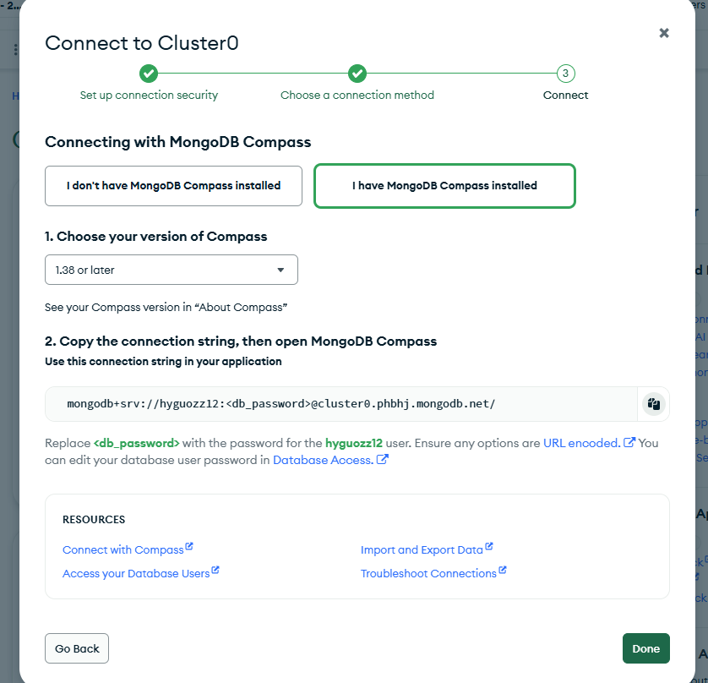
3. In Compass, create a new connection, paste the connection string into the URI field, and replace db_password with your MongoDB Atlas account password.
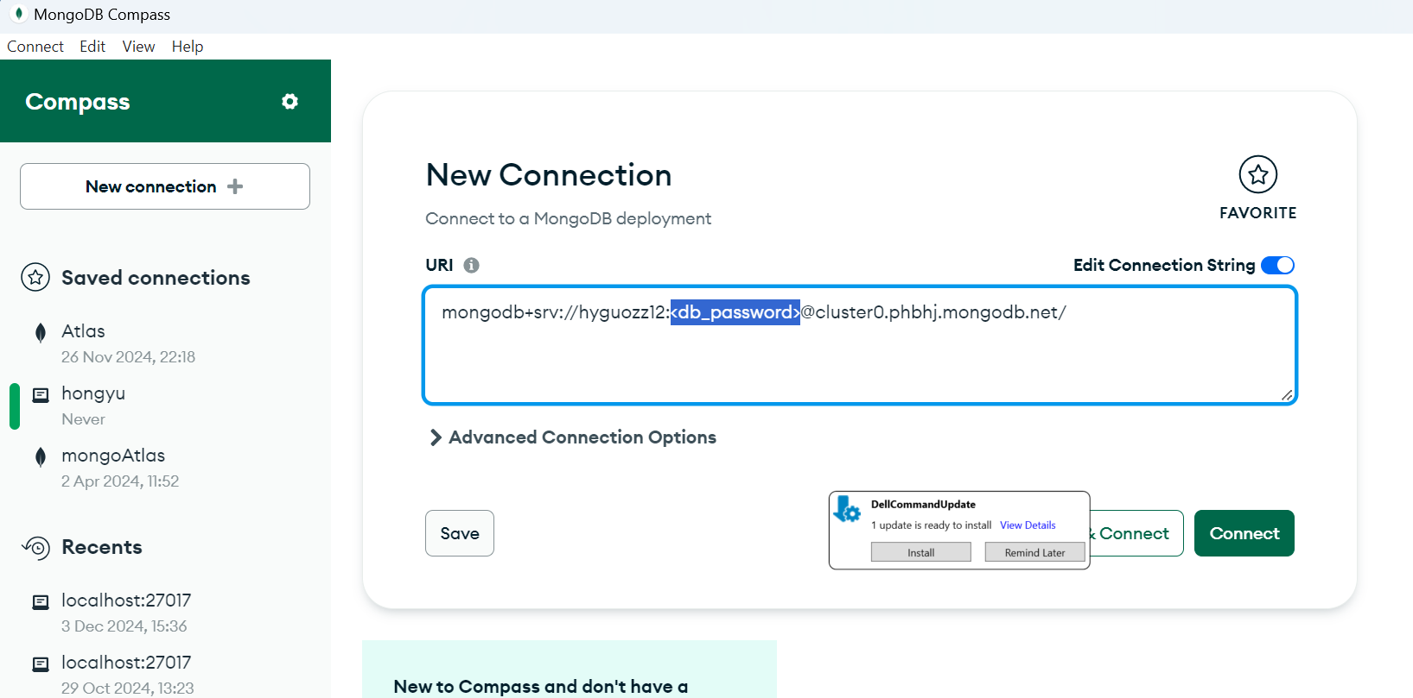

4. After logging into MongoDB Compass, you will see a window like the one below. Click Create Database, set up your database and collection, and then proceed to import data.
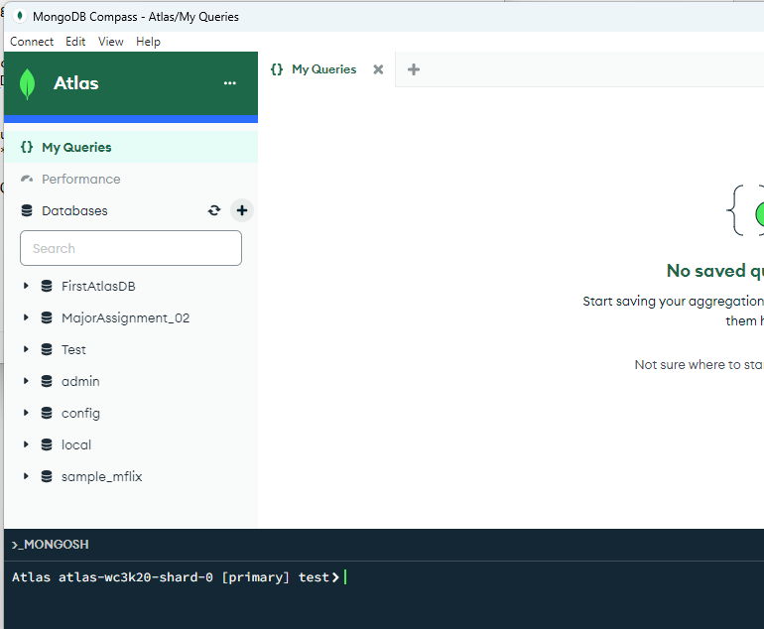
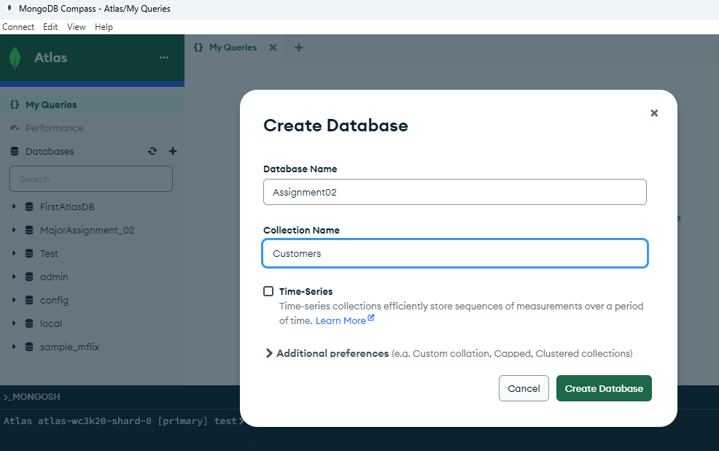
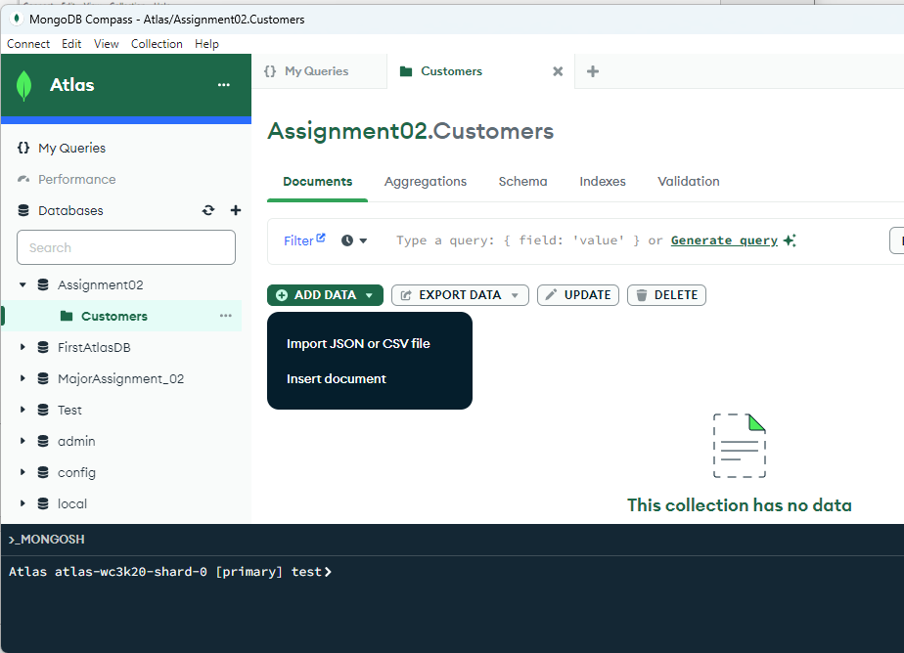
Click ADD DATA to import your data file into MongoDB Atlas. This process uploads your local data file to the cloud, making it accessible in your Atlas cluster.
5. Go back to MongoDB Atlas, Click Charts, then Add Dashboard, Add Chart
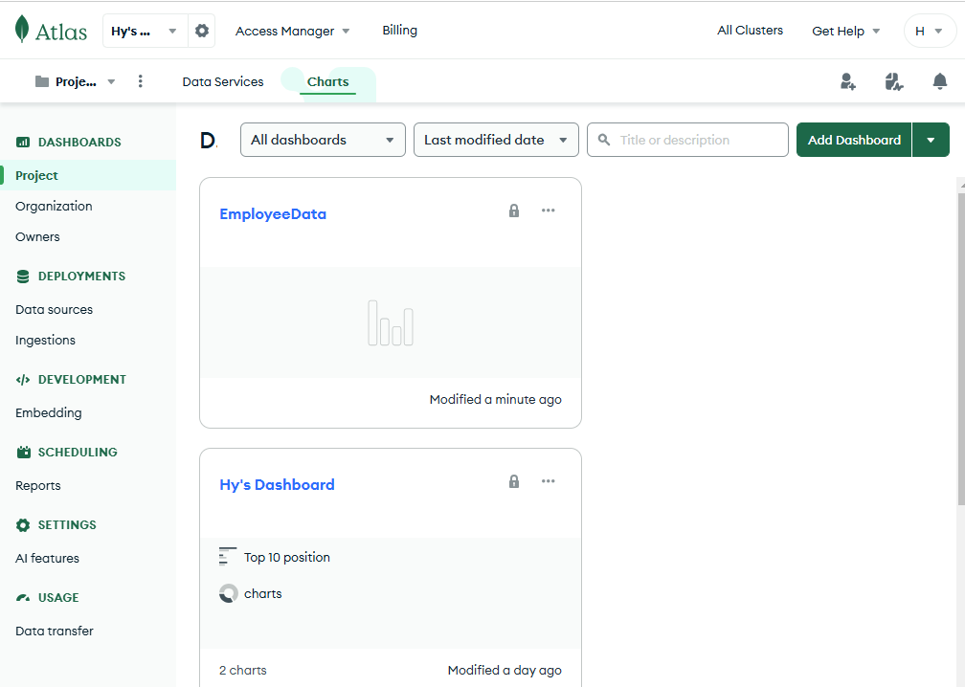
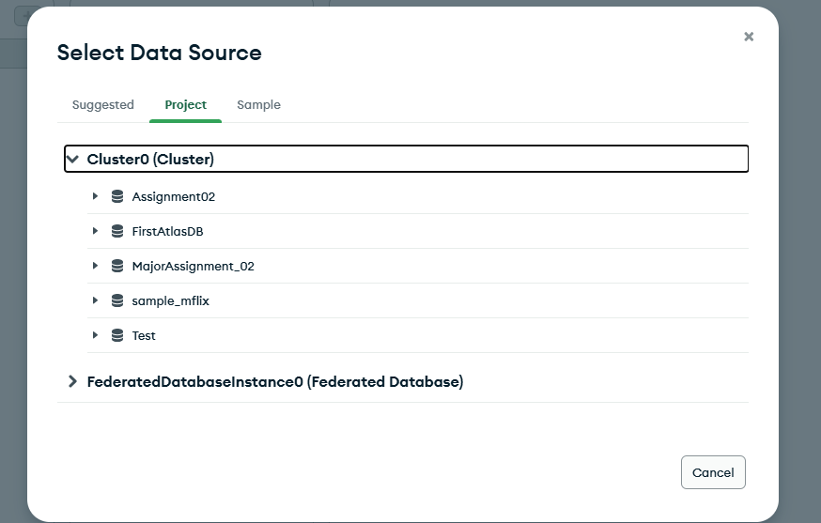
6. In the Add Chart window, the fields of the collection are listed on the left side. Drag the desired fields and drop them into the appropriate sections on the right side, such as Encode - X Axis, or Y Axis.

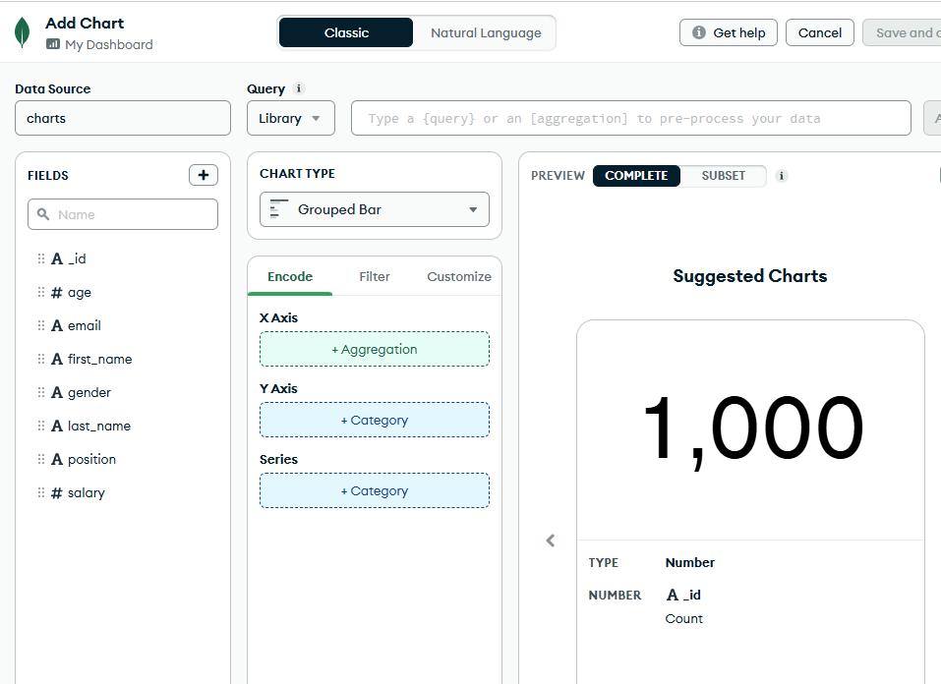
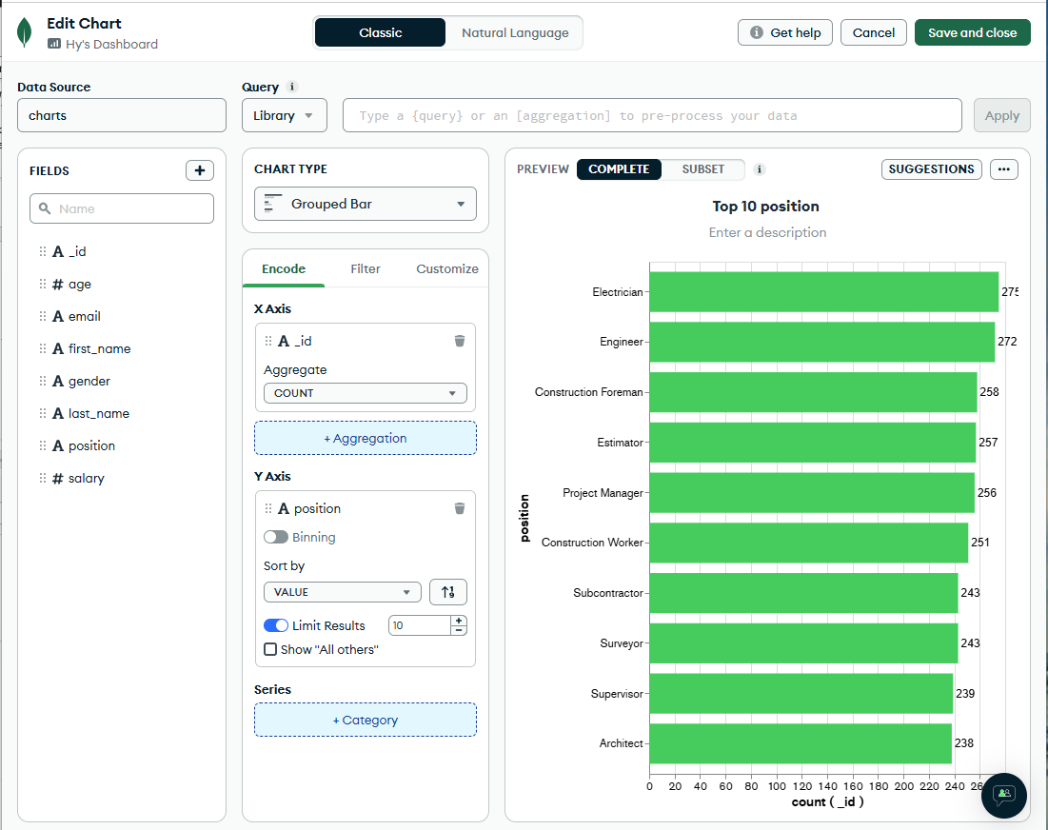

Then, click the Customize tab to personalize your chart's appearance and settings.
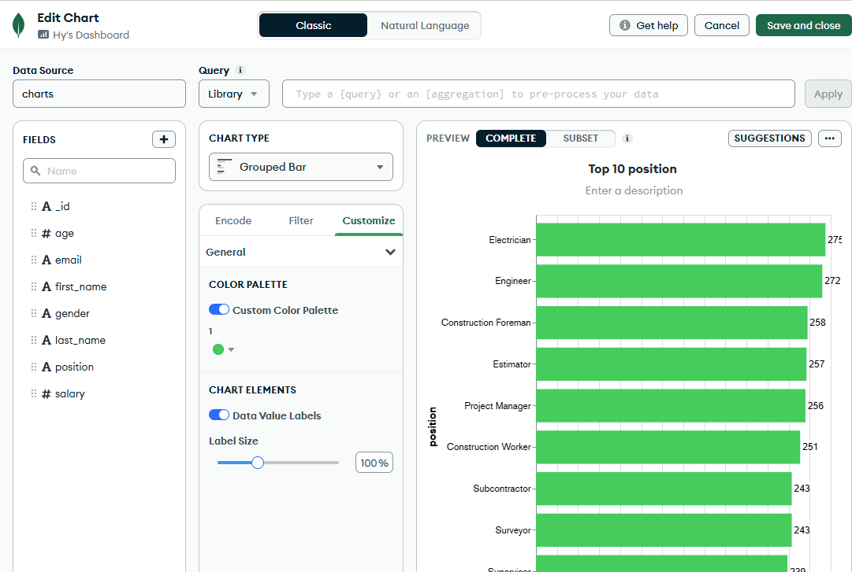
Create a donut chart, as shown below.
